**How to install dlib**

If you want to install dlib in windows on the latest python version you are in right document.

Don’t worry by following the below steps you will be able to install dlib easily but follow these steps procedurally.

**How to install dlib?**

Dlib is library which will require the complier of c/ c++ to execute its installation as it is written in c++,So it requires cpp.

So if you haven’t installed cpp tools **errors like CMAKE_C_COMPILER error, Failed to build Wheel, CXX complier error** and by many more other names will occur.

Now there is the solution and the steps which must be followed while installing the dlib. Follow these steps in right manner and if you have installed dlib before then just uninstall it by running cmd as administrator (command is-**pip uninstall dlib** ).

If anyone has tried to install dlib manually by copying the files of dlib to site-packages of python and please delete all the folders of dlib you have pasted in site packages of python.

So now we will start:

**Step1**:Run command prompt in your windows as administrator.

**Step2:** dlib library requires cmake to download before its installation . So install cmake by typing a small command- **pip install cmake**

**Step 3:** After this you have to **install visual studio tools** so download (vs tools 2019 or vs tools 2017)

<https://visualstudio.microsoft.com/downloads/>

**there would be community download available download that**

**Step 4**: You have to **install Visual studio build tools 2017** from it. I have installed it, so I am going to click on modify and proceed to next step.

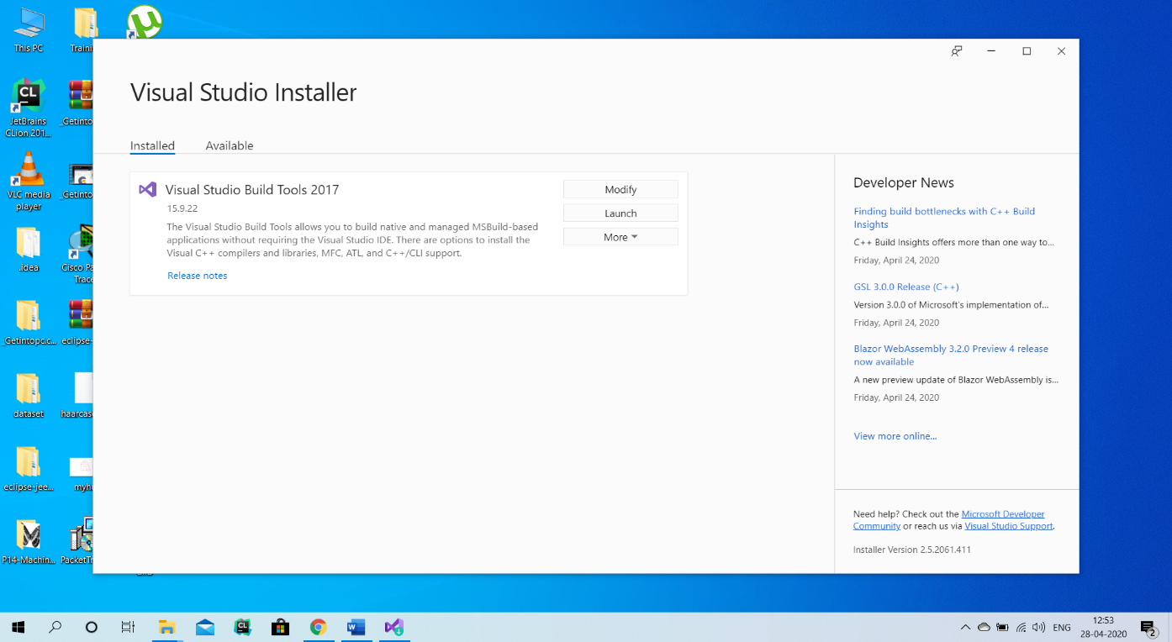

**Step 5:** Download the visual C++ build tools it would be around 4.5gb.

**Caution: Don’t change the default ticks on the right-hand side in optional in installation details.**

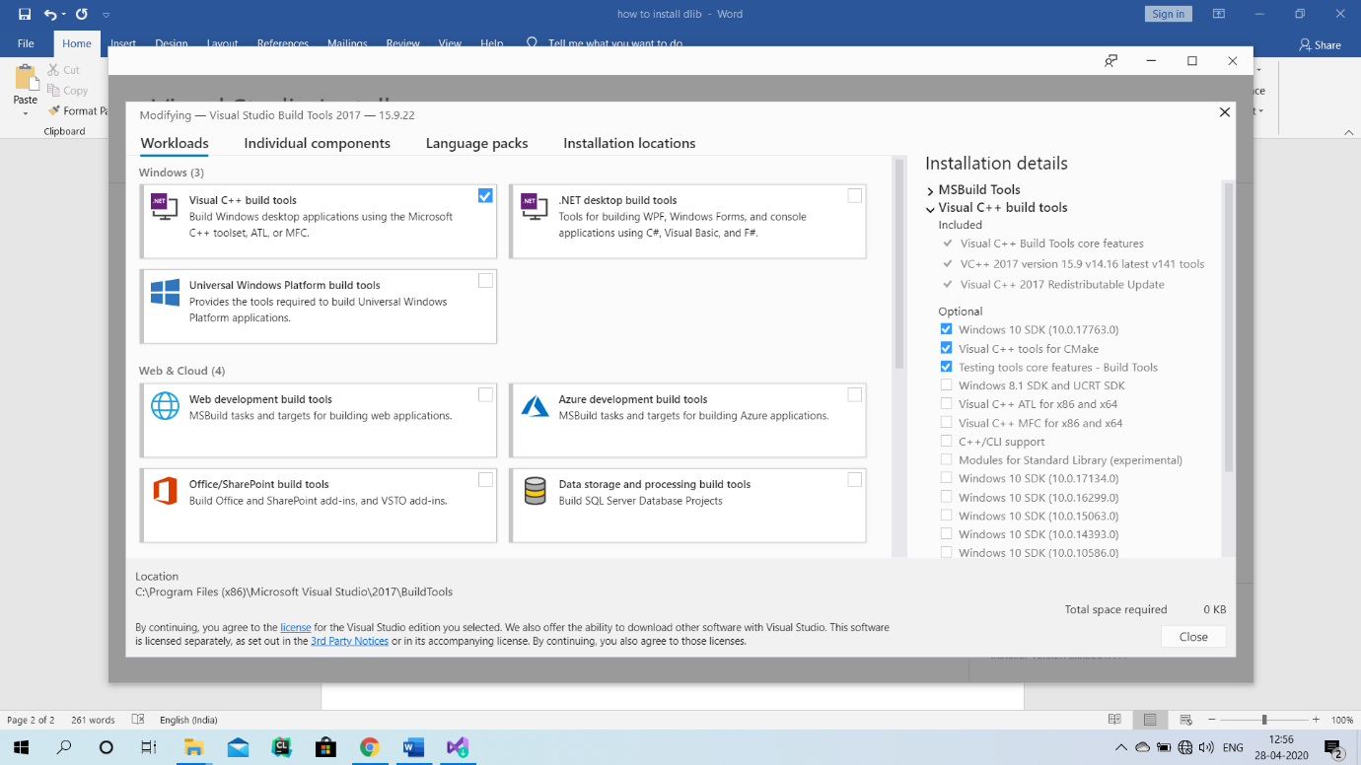

**Step 6:** After the download get complete ,run command prompt as administrator and type command -**pip install dlib .**

**Here is a tip for you all: Don’t get frustrated as while you type this command the cursor will blink on building wheels for a long time. So be patient till it is done** .

And you can download the face recognition library if you wish so by -pip install face _recognition

**If my explanation is unclear then you can see this video too 🡪** <https://www.youtube.com/watch?v=TC_LPpa7uj0&t=1s>

THANK YOU

From: Shrey Bansal